***Term Project***

**Effective Waste Disposal Application**

***By*** *Shivam Thakur*

*thakur.shiva@northeastern.edu*

Submission Date: *April 10, 2022*

EMGT5220: Engineering Project Management, Fall 2021

Northeastern University

Instructor: Prof. George Kontopidis

Table of Contents

1. Purpose 3

2. Objective 3

3. Scope 3

4. Funder/Investor 3

5. Critical Success Factors 3

6. Assumptions 3

7. Technical Approach 4

8. Organization 4

9. Project Plan 5

a. Work Breakdown Structure (WBS) 5

b. Resource Plan and Responsibilities (RACI) 6

c. Financial Plan 6

d. PERT Chart 8

e. Gantt Chart 10

10. Risk Assessment (SWOT, FMEA, RPN) 13

11. Monitoring and Control 18

12. Summary 18

13. Appendix 19

a. Mind Map 19

b. Activity Diagram 20

c. Sequence Diagram 21

14. References 22

**Revision History**

|  |  |
| --- | --- |
| 01/30/2022 | Draft #1: Original proposal |
| 02/20/2022 | Draft #2 |
| 03/23/2022 | Draft #3 |
| 04/10/2022 | Final Project Report |
| 04/12/2022 | Final Project Presentation |

## Purpose

We believe in a healthier, cleaner environment and towards a sustainable future for the city of New England, Boston. To achieve the above, we have undertaken this project to assist our users in the first step of waste disposal by providing the nearest disposal bins and efficient feedback for proper removal, specific to the waste.

## Objective

The project aims to develop an online application responsible for providing the user with the location of the waste bins in the near vicinity, giving suggestive feedback appropriate for proper waste disposal, and also motivating them to follow the instructions via a reward-based system which can later be redeemed in form of energy point for electricity bill from Eversource.

## Scope

The scope of this project is to develop an online application that helps its user find nearby waste bins while providing an effective way to dispose of the waste. The application also provides the user with a monthly pollution index, their contribution towards the change, and motivates them to follow suggestive instructions via a reward-based system. The team is also responsible for collecting data on waste disposed effectively and calculating reduction in carbon footprint.

## Funder/Investor

This project will be funded by Eversource and will enable the organization to go one step ahead towards a sustainable future. The application collects data on the waste disposed of by the user signed up with an ownership agreement over the waste. The project will establish B2B relations with the Massachusetts Department of Environmental Protection, providing the organization with pre-calculated carbon points and subsidies which will be analytically shared with the user and will also weigh in towards carbon-neutral goals of the organization. In short term, effective marketing actions are planned to be implemented in collaboration with the Massachusetts Department of Environmental Protection which predicts a spike in the stocks of the company can be seen while in long term a higher market capitalization can be achieved.

## Critical Success Factors

The successful completion of the project is majorly dependent of the following factors:

1. Successful development of carbon points collected through disposed garbage to reward based system
2. Cybersecurity is a priority to secure the data hub and servers.
3. Using checklist to keep track of the progress of each task.
4. Keeping the size of the application to a minimum to avoid unnecessary lagging between day-to-day functions.

## Assumptions

1. Access to all the resources needed to complete the project, human and technology is available.
2. The resources needed are available and in working condition without any delay according to the plan during the project lifecycle
3. Personal cost will not be charged during the project.
4. The total cost of daily operations remains the same
5. The scope of the project remains unchanged throughout the project’s lifecycle.
6. The application is only used on devices having dual core processor or a device with higher processing strength.

## Technical Approach

The project will require development of a user-friendly application with an effective way to convert the waste collected into a carbon footprint; a Hub which includes, high storage data servers, high speed internet access, high -RAM systems integrated with platforms for mobile app development, UI/UX software and graphic design software. The project will also utilize transportation vans, precise GPS locators and photography equipment to get updated location of the waste bins periodically.

## Organization

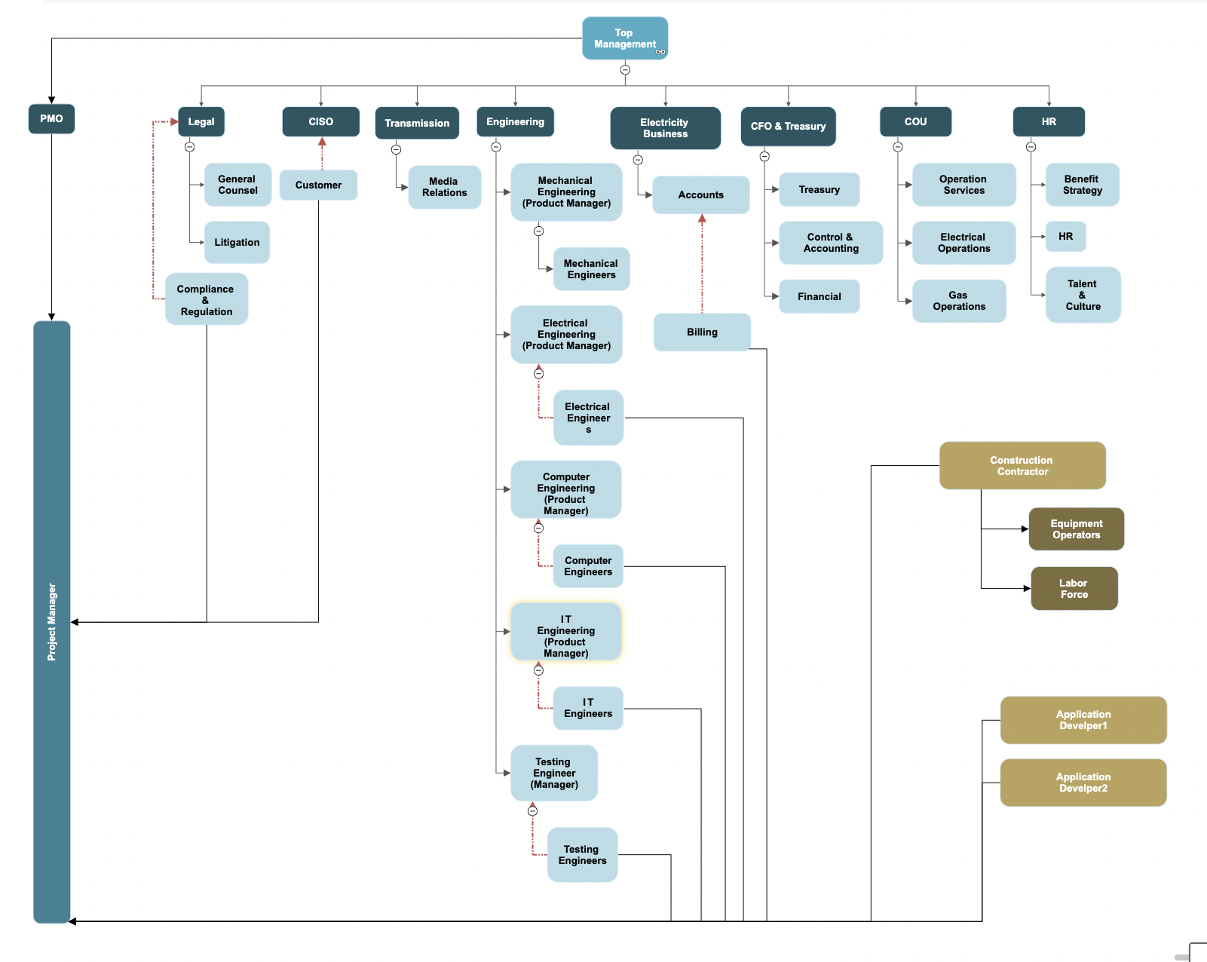

Table. 8.1

**Eversource Integrated Organizational Chart**

The organizational chart follows a strong-matrix formation where the Project manager is reporting to the PMO in control of the top management. This type of project provides flexibility to the project and ability to utilize resources available in the organization as per needs, hence improving the success factor of the project.

## Project Plan

### Work Breakdown Structure (WBS)

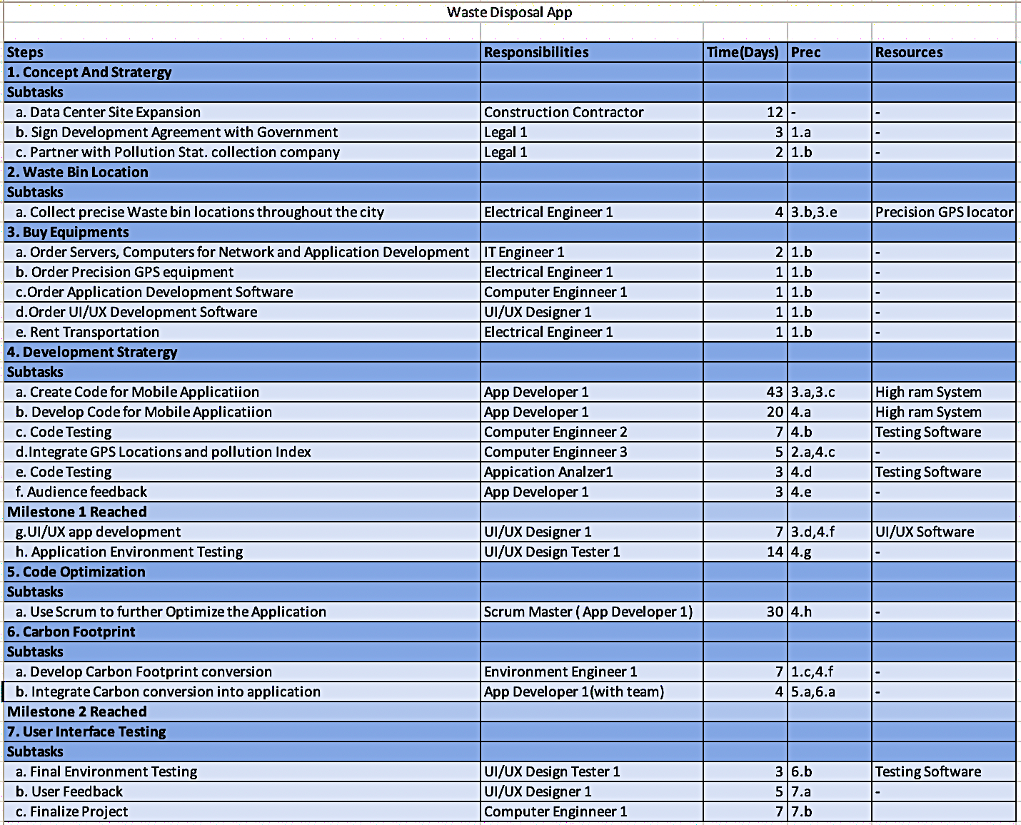

Table. .

**Work Breakdown Structure**

The above WBS shows the tasks to be accomplished with milestones set in order to monitor the growth and completion of the project. It also shows the tasks that are needed to be achieved before taking upon a certain task with the professional responsible for the completion of each particular task, essential resources are also mentioned to accomplish certain tasks.

### Resource Plan and Responsibilities (RACI)

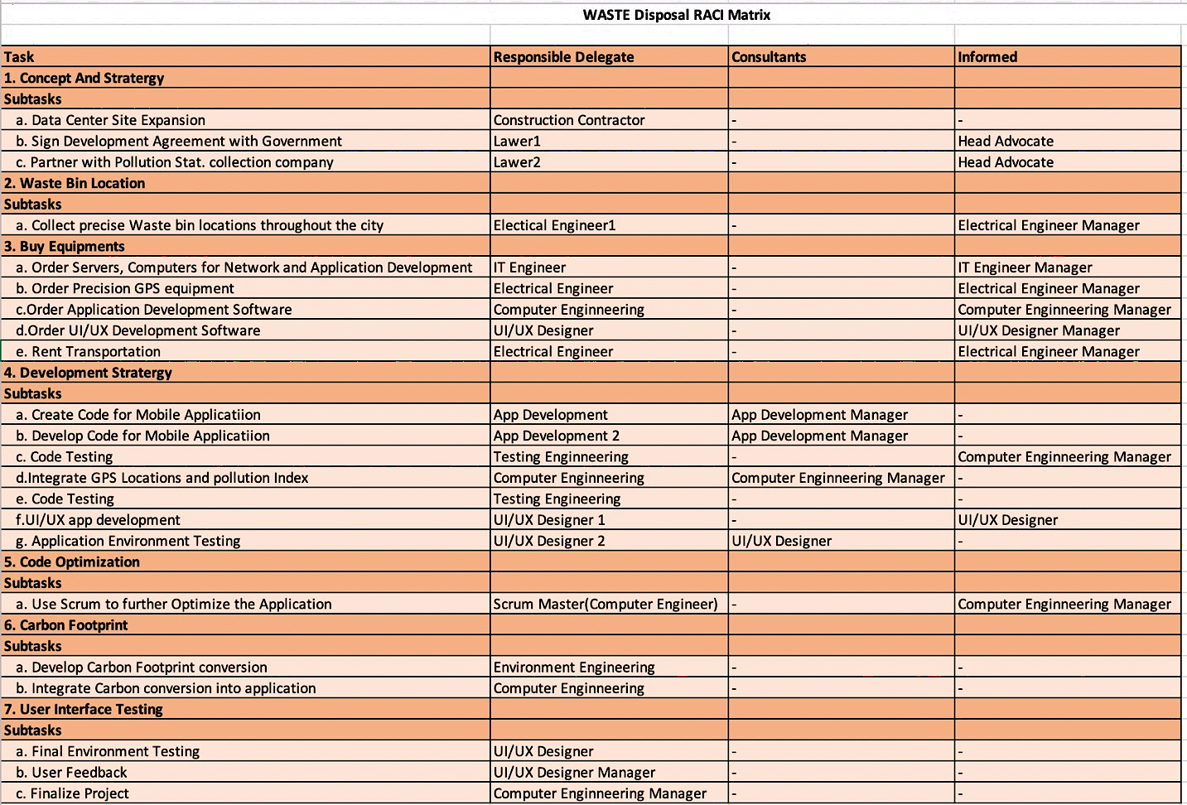

Table. .

### Responsibility Matrix

The Responsibility matrix assigns each task to a certain professional, while assigning someone to support. It helps in monitoring the growth while dividing the work among the team and diminishing the confusion within individual tasks. The assigned individuals are also responsible to inform the growth of the task respectively in order to monitor, identify and evaluate the risks pertaining to each task and take further actions to curtail them efficiently, hence reducing the risk factor.

### Financial Plan

Table. 9.3

**Project Based Financial Budget**

The financial plan follows a projectized budget where the tasks are divided according to the particular budget and their individual tasks are stated with the resources utilized. The resources are monetized according to their needs and the total monthly budget has been calculated with the estimated budget for individual section giving us a grand total budget for the project **$4,800,000,** keeping in check in unknown-knows and the known-known risk factors.

### PERT Chart

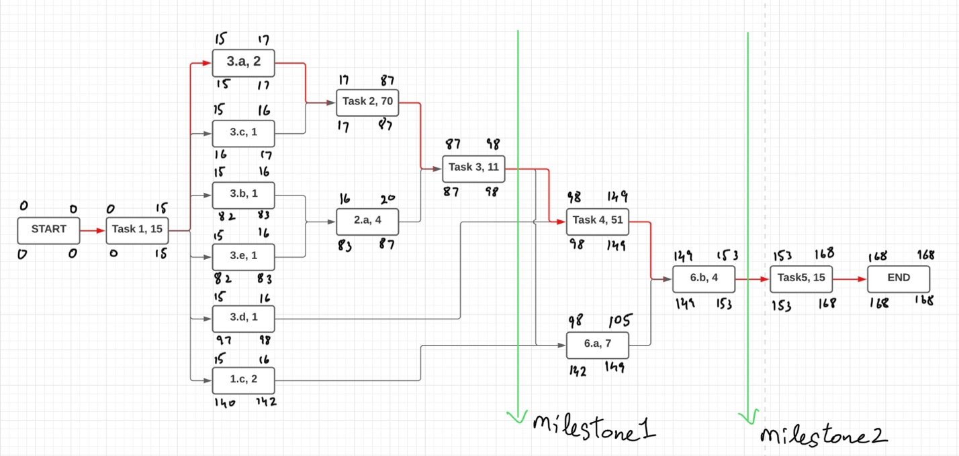

Fig. 9.1

The PERT chart (Fig. 9.1) shows the cumulation of tasks in series as shown below:

1. Task1 : 1.a(12) + 1.b(3)
2. Task2 : 4.a(43) + 4.b(20) + 4.c(7)
3. Task3 : 4.d(5) + 4.e(3) + 4.f(3)
4. Task4 : 4.g(7) +4.h(14) +5.a(30)
5. Task5 : 7.a(3) + 7.b(5) + 7.c(7)

The early start(ES), late start(LS), early finish(EF) and late finish(LF) is calculated and the critical path is found, START-Task1-3.a-Task2-Task3-Task4-6.b-Task5-END.

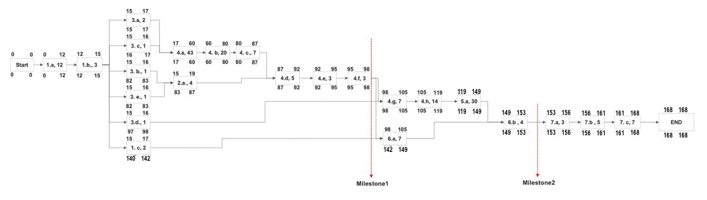The above PERT chart shows the individual tasks with ES, EF, LS and LF calculated.

Fig. 9.2

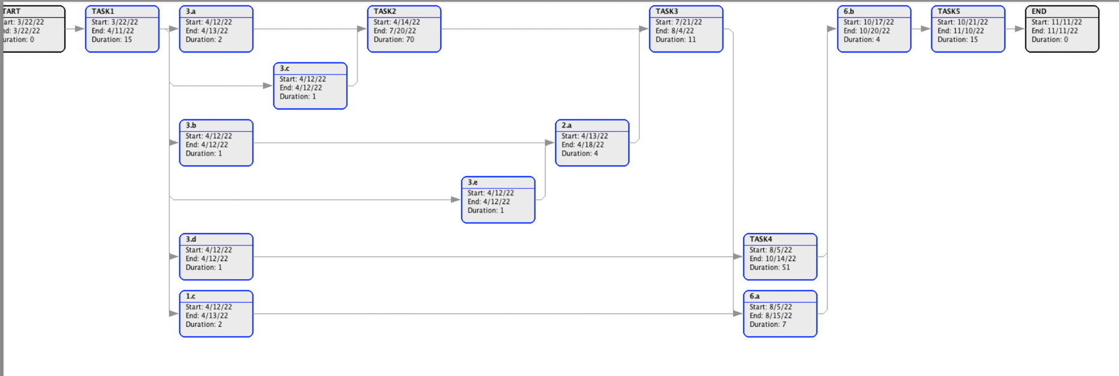

Fig. 9.3

The above PERT chart depicts the PERT chart of cumulative tasks from Gantt project as shown in *Fig. 9.1*

### 

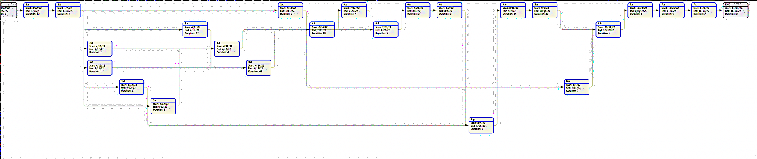

Fig. 9.4

The above PERT chart depicts the PERT chart of individual tasks from Gantt project

### Gantt Chart1

Fig. 9.5

Gantt chart based on the WBS, *Table 9.1*

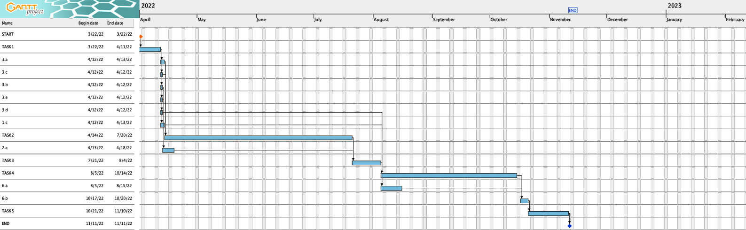

Fig. 9.6

Gantt chart based on cumulative tasks as shown in *Fig. 9.1*

## 

Fig. 9.7

Gantt Chart post adding resources, the resources were added according to the tasks

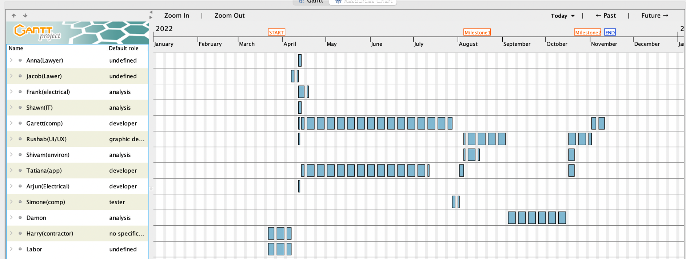

Fig. 9.8

The *Fig. 9.8* shows the resource loading for the project team as shown above.

## Risk Assessment (SWOT, FMEA, RPN)

1. **SWOT**

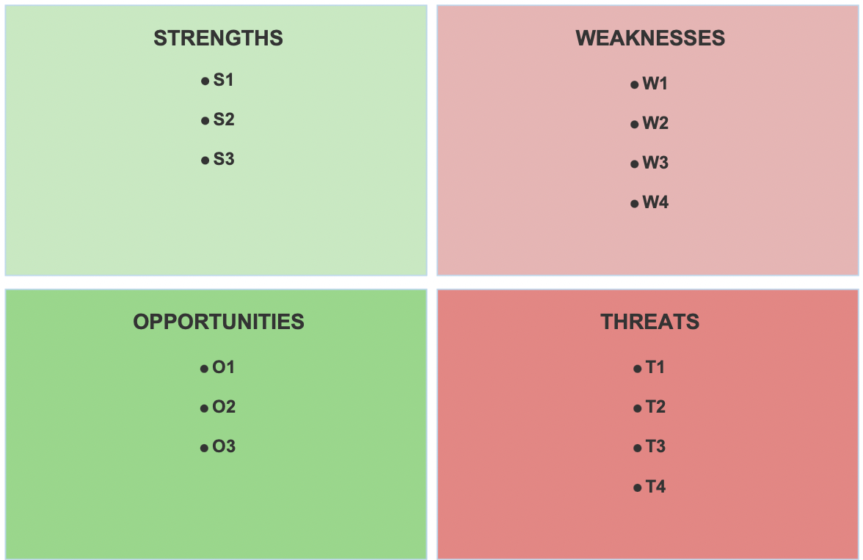

Fig. 10.1

1. S1: Flexibility to use the resources throughout the organization as per need.
2. S2: Access to expertise knowledge.
3. S3: Following upon re-existing steps of sustainability.
4. O1: Changing consumer behavior about sustainable development.
5. O2: Higher Market Cap. by attracting new customers.
6. O3: Building upon pre-existing government relations with joint venture.
7. W1: Unclear roles of staff involved in project, unclear product specifications with contractor to whom work will be outsourced.
8. W2: Delving into new territories-developing, conversion of waste collected into reward system.
9. W3: Network dependent Application, lack of efficient and smooth flow of data within the application can delay the function, causing unwanted lags.
10. W4: Lack of visibility into progress, dealing with multiple departments lack of communication can be complex and lead to losing focus on the progress.
11. T1: Change in government policies, change in government policies regarding recycling of waste will require amendments and adapting according to it.
12. T2: High data processing mobile devices required, the data flow of application being high, the device used by the user is limited to mobile devices having dual core processor and higher.
13. T3: Cyberattacks, external tapping into servers can corrupt the stored data.
14. T4: Lack in Hub-safety, considering in event of an accident, safety measures are required to ensure safety of human resources as well as the data servers.
15. **FMEA**

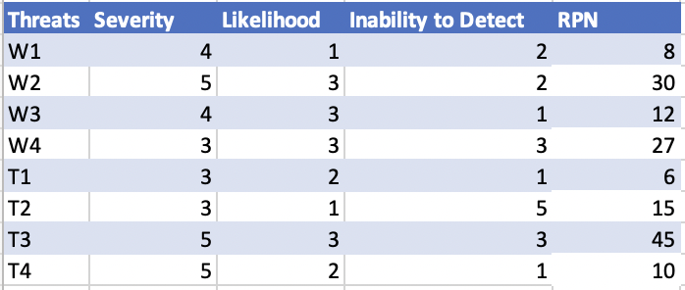

Table. 10.1

The weaknesses and threats are listed and evaluated based on a score of 1-5,

1. The possibility, severity is very low in case the event takes place.
2. The possibility, severity is low but is adaptable in case the event takes place.
3. The probability of failure and the possibility of the event happening is 50%, it will be hard to adapt accordingly.
4. In case of the event sufficient damage could lead to failure of project.
5. The possibility, severity is very high in case the event takes place.
6. **RPN**

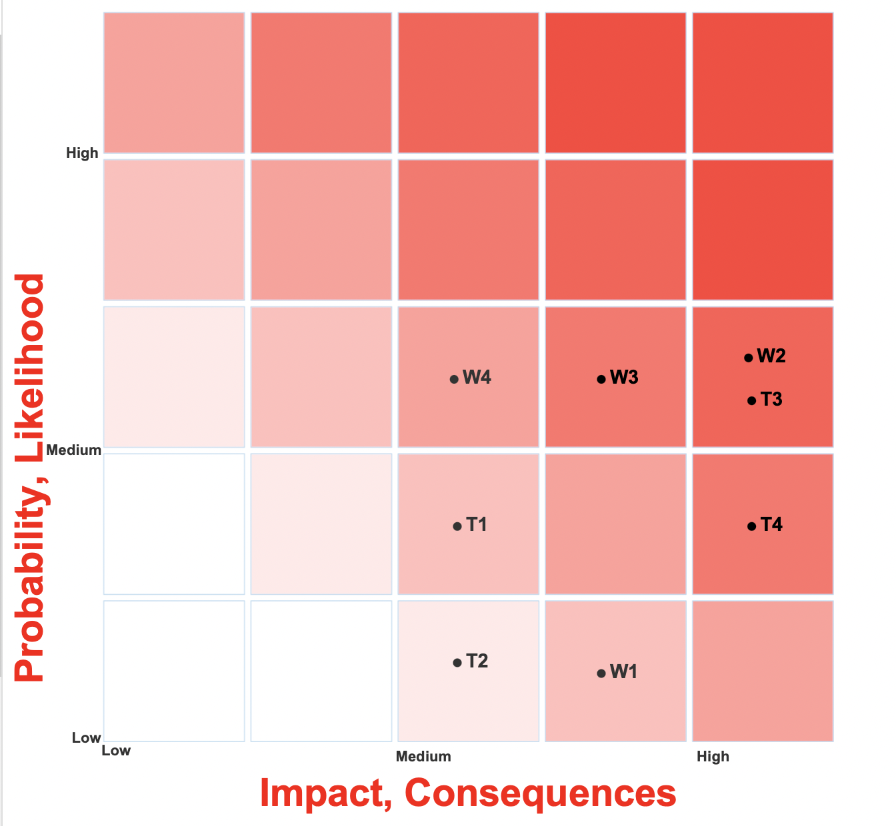

Fig. 10.2

The values of likelihood and severity assigned are used to plot the weaknesses and threats on the basis of respective probability, likelihood and impact, consequence 5X5 matrix above.

1. **Mitigation Plan**
2. The project accomplishes it’s functional purpose by storing data which is undergoes monetary conversion for the user hence the data needs to be secured and network security should be prioritized to avoid cyberattacks.
3. Delving into new technology can be challenging, to achieve such without any hinderance the legal team will develop a patent based on the developing technology to enhance project security and minimize risk.
4. To avoid any scope creep and delays in tasks, Jeera software will be used with checklists which will monitor task completion.
5. The data hub will be insured, with fire safety steps taken in case of an accident. In case of an accident the damage can be avoided with the planned precautionary steps and the equipment risk is shared with the insurance.

## Monitoring and Control

The project undergoes several checkpoints to make ensure successful completion of essential tasks required to complete the project with planned milestones 1 and 2.

The project team working are assigned to people they need to keep informed in order to track the progress.

It is essential to give the project team space to be able to generate new ideas therefore a checklist has been introduced which is used to monitor the progress of the project with the Jeera software in a timely manner (2 weeks).

## Summary

Healthy surroundings and sustainable cities are a topic of prime focus for the growth of a city and health of its residents.

To help such and avoid garbage on the streets this project is undertaken to develop a web application which helps its user find the nearby garbage bin, post- scan of the garbage provides disposal-feedback according to the garbage, the users also earn points upon disposal they can use to pay their Eversource electricity bill and motivate them by providing individual and city pollution stats and change introduced.

To ensure the above scope to be achieved within a budget of **$4,800,000** and within 168 days tenure (6months 18 days) considering all the resources, risks and quality management into consideration while giving highest priority the three constraints that are scope, budget and time.

## Appendix

### Mind Map

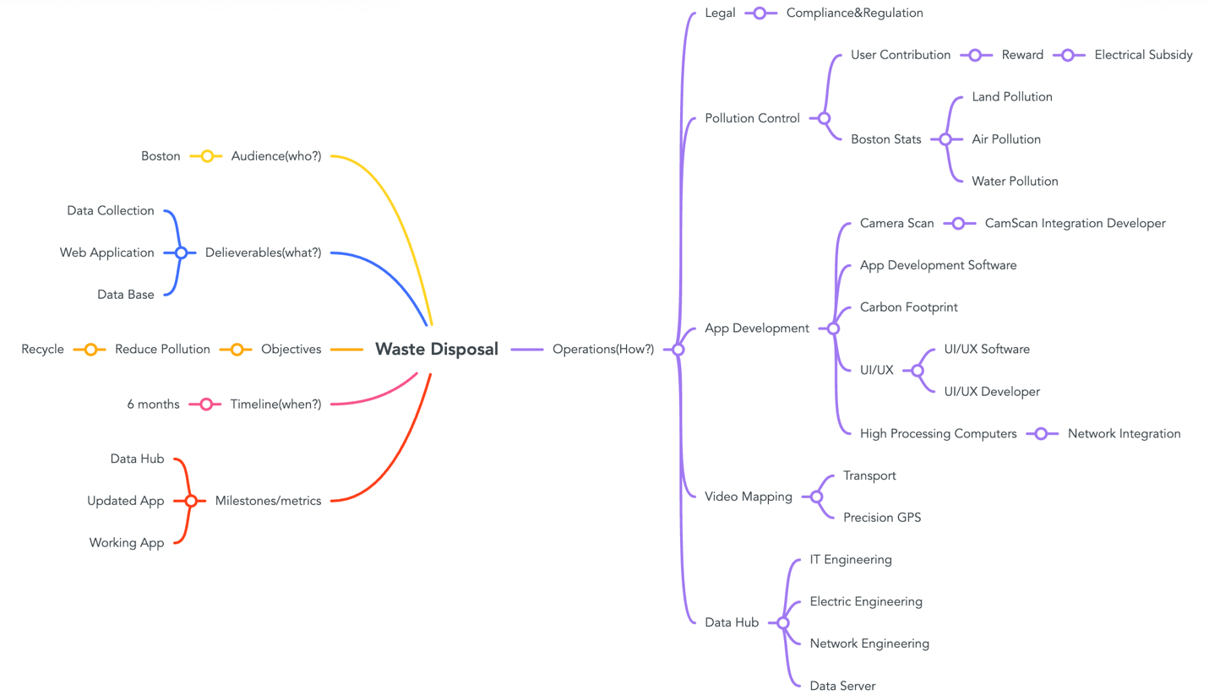The mind map shown below *Fig 13.1* distributes the project and into segments as shown below,

Fig. 13.1

### Activity Diagram

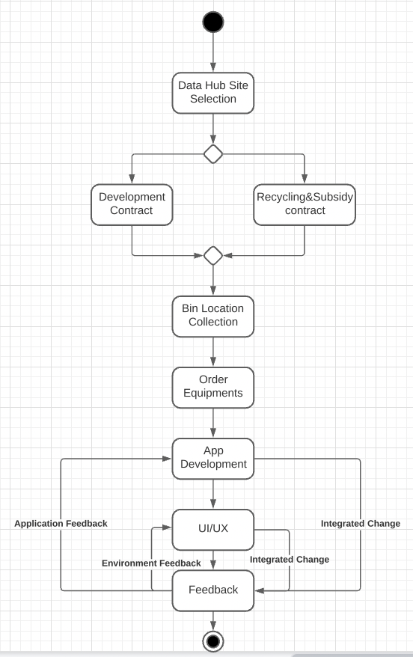

Fig. .

The Activity diagram shows the sequence between tasks undertaken under the project and the correlation between them.

### Sequence Diagram

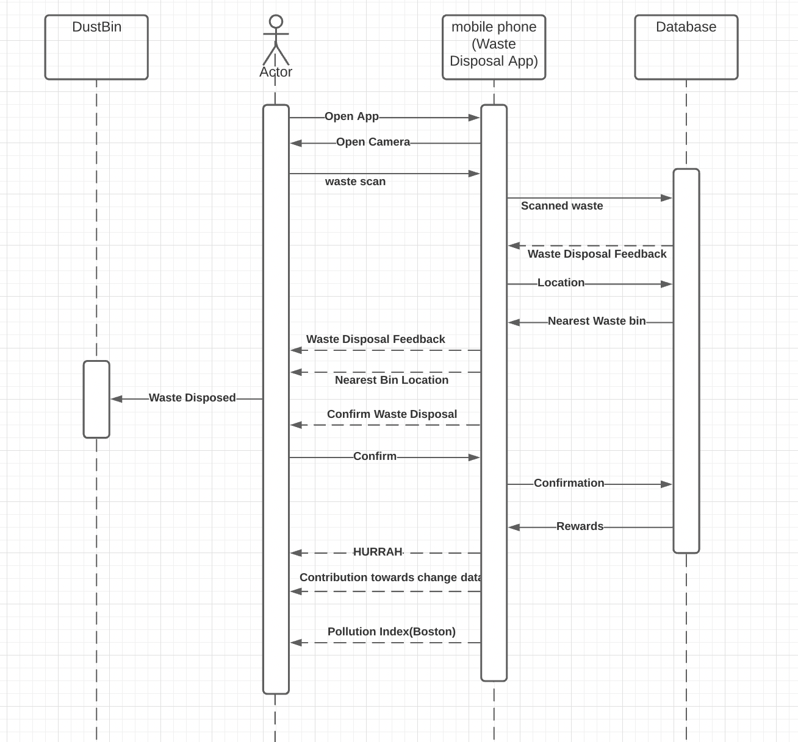

Fig. .

The above figure *Fig. 13.3* shows the sequence followed by the user within the web-application through the sequence diagram.

## References

<https://www.workfront.com/project-management/life-cycle/monitoring-controlling>

<https://www.wrike.com/blog/what-are-project-assumptions/>

<https://bestprac.eu/fileadmin/mediapool-bestprac/intern/STSM/STSM_TN1302_weaknesses_FINAL.pdf>

References from the book “Project Management- A Strategic Approach by Jack R. Meredith and Scott M. Shafer”